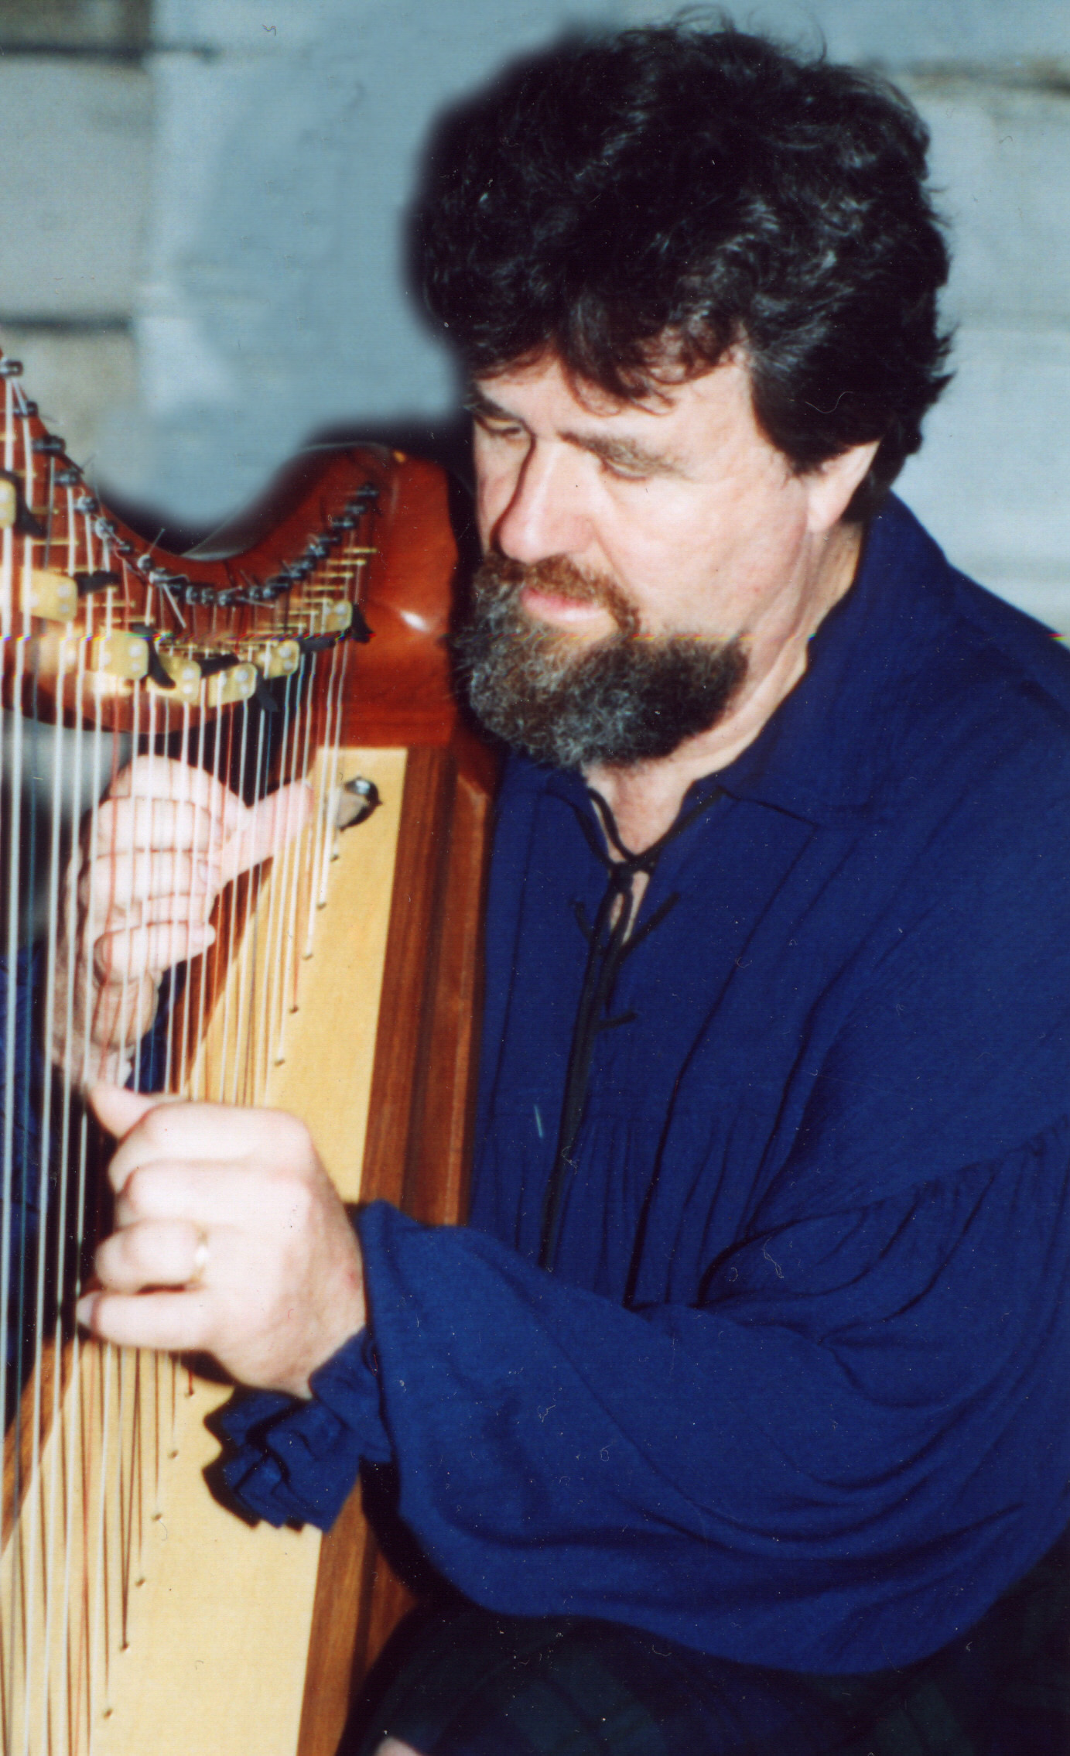
Rick Stanley is an award-winning singer/songwriter/ guitarist/harper and harp-maker. These days he designs and builds custom folk harps and performs the music of his Celtic-folk roots. He embodies the resurgence in the late 20th century of the ancient oral tradition of performance, and the rekindled interest in the folk lever harp -- emblem of Irish nationalism since the 10th century. Rick’s innovative rhythmic and complicated picking style on Irish harp stands in stark contrast to the simple chords often plucked by modern troubadour harpers.
Rick has had a long career in folk music as a guitarist and singer/songwriter. He started performing in the coffee houses of Boston, New York and ultimately the West Coast where Columbia Records signed him. Under Byrds producer Terry Melcher, Rick Stanley and Pam Polland as “The Gentle Soul” made the charts with two singles, and their self-titled album on the Epic label was called “Most beautiful…album of the year” by Billboard Magazine. Sony/Sundazed Records released the complete recordings of The Gentle Soul in March 2003.
Rick worked or recorded with some of the most talented musicians in the business: Linda Ronstadt & Kenny Edwards, Ry Cooder, the Beach Boys, Glen Campbell, Al Kooper, Jackson Browne, Steven Stills and many others. The next decade found Rick living in Europe and touring the world, all the while writing songs for two more highly acclaimed albums recorded at A&M Studios in L.A. with Joni Mitchell’s talented producer, Henry Lewy.
Years before the recent Celtic renaissance, Rick recorded a powerful album called On English Hills, containing some of his favorite Scots, Irish and English ballads and a few of his originals. Rick is a world-class guitarist, but once he started singing with a Celtic harp Rick found the perfect accompaniment to his rich “Cat Stevens” voice, as can be heard on his solo effort The Ballad of Bothwell & Marie.
Because his formative years were not only filled with music, but as apprentice to a master cabinetmaker, Rick succeeded at designing and building both nylon and wire-strung harps (visit his website at www.celticharps.com). The last decade has been dedicated to creating masterpieces out of wood, glue and consciousness and, of course, an equal amount of Rick’s time has been given to mastering the accompaniment of his ballads and original songs with his hand-built harps. Rick performs either with his group Border Lord, or as a solo artist often accompanied by Irish fiddler Tara Dutcher and Claudine Stanley on bodhran.

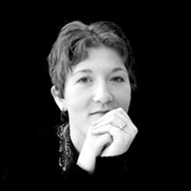

Tara Dutcher’s formal training in violin began at the age of 3 with classical violin training in the Suzuki method but with an Irish fiddling mother and a bluegrass fiddling paternal grandfather, there were early indications that Tara’s musical interest would extend beyond the classical realm.

Not one to separate her art and her life, Tara holds a degree in music therapy from The University of Iowa and is a board-certified music therapist and former Director of Music at Iowa City’s nonprofit School for the Performing Arts. Tara performs regularly with the Celtic band The Beggarmen as well as with the more classically oriented Ariel String Quartet.

TARA’S DISCOGRAPHY

i shall, 2005, performing with The Beggarmen.
See Other Side

RICK’S DISCOGRAPHY
Bonny Brave Boys, self-produced, 2003. Traditional and contemporary ballads and airs performed on vocals, harp, cello, guitar, bodhran and whistle. Features Border Lord’s most inspired and subtle artistry, captured live by Chulrua’s producer and audiophile Tim Britton, who also joins in on flute and whistle. Chulrua’s guitarist/vocalist Pat Egan is also featured.
The Ballad of Bothwell & Marie, self-produced, 2001. Traditional and contemporary Celtic ballads on harp, guitar, cello, harmonium, bodhran.
On English Hills, self-produced, 1983. Traditional Irish, Scottish and English ballads folk-rock style on guitar, penny whistle, hammered dulcimer, highland pipes, drums, bass
In the Golden Dome, produced by Mac Gayden at Broken Door Studio, Nashville, 1980. Contemporary folk-rock with Rick Stanley on guitar and vocals; Mac Gayden on slide guitar, bass; Buddy Spicher on fiddle, violin, cello; and Biff Watson on synthesizer, harp, drums.
Something Good is Happening, produced by Henry Lewy at A&M Records, 1972. Beautiful new age music written and performed by Rick Stanley and The Loading Zone’s Paul Fauerso.
Song of Life, produced by Henry Lewy at A&M Records, 1970. Original new age music with Rick on guitar and vocals and Paul Horn on flute.
The Gentle Soul, produced by Terry Melcher, Columbia Records, released on Epic label, 1969. Rick Stanley--vocals and guitar, Pam Polland--vocals, Ry Cooder--slide guitar, mandolin, and Van Dyke Parks on harpsicord. NOTE: The complete works of The Gentle Soul were re-released March 2003 by Sundazed Records.

SOME OF RICK’S VENUES:

The Troubadour (CA)
The Golden Bear (CA)
Club 47 Mt. Auburn (MA)
Milwaukee Irish Fest (WI)
Amherst College w/The Beach Boys and Mac Gayden (5,000+ audience)
MIT and other colleges throughout the US
Mallorca, Spain; Fuji, Italy; Germany (2,000+ audiences)
Wybreg Renaissance Faire (IA)
All Things Scottish Celtic Fest (IA)
The Mill (IA)
The Sanctuary (IA)
Colonial Inn (MA)
Perpetual Folk Festival (IA)
House and other concerts throughout the U.S.

RICK’S AWARDS, ETC:
2002 Recipient of Traditional Arts Award, Iowa Arts Council.
Appeared on November 2003 music spotlight, LIVING IN IOWA
Page 2

“… Rick Stanley is a world-class musician, arranger and artist who has performed or recorded with many great musicians: Paul Horn, (Mike Love), Glen Campbell, Ry Cooder, Hoyt Axton, Steven Stills and other fine musicians in his long career with Columbia and Epic Records. Rick is one of those rare musicians who were first in line when talent was being passed out…”(Eric Cathcart, The Kilt & Harp, Winter 2002).
For Bookings, contact:
SARADA ENTERTAINMENT
(641) 209-7664
www.saradainc.com
bookings@saradainc.com
b

