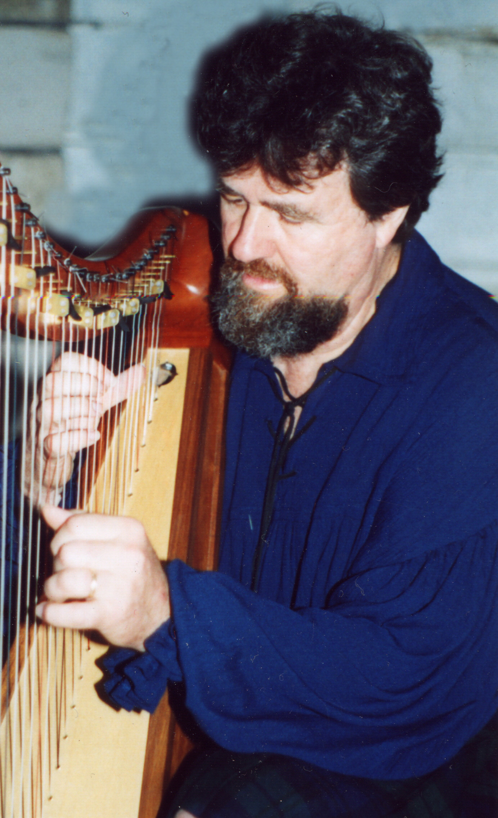

Rick Stanley

Singer/Songwriter and Harper

Rick Stanley is a singer/songwriter/guitarist/folk harper and harpmaker. These days he designs and builds custom folk harps and performs the music of his celtic roots. Rick started singing in the coffee houses of Boston, New York and the West Coast where he was signed by Columbia Records. Producer Terry Melcher, who made the magic of the “Byrds” hit albums, took on the role of manager and producer to Rick and Pam Polland, “The Gentle Soul.”
They made the charts with two singles, “Tell Me Love,” written by Rick and “She’s a Flying Thing that Sings” written by one-time member of The Gentle Soul, Jackson Browne. The self-titled album, on the Epic label, was called “Most beautiful…album of the year” by Billboard, the top trade magazine for the music industry. The complete recordings of The Gentle Soul was released by Sony/Sundazed in March 2003.
Rick has worked or recorded with some of the most talented musicians in the business: Ry Cooder, Kenny Edwards, the Beach Boys, Glen Campbell, Al Kooper, Jackson Browne, Steven Stills and many others. The next decade found Rick living in Europe and touring the world, performing in venues from pubs to the palaces of Emperor Haille Selassie and the King of Nepal. All the while, Rick was writing the songs for two more highly acclaimed albums recorded at A&M Studios in L.A. with Joni Mitchell’s talented producer, Henry Lewy.
Years before the recent Celtic renaissance, Rick recorded a powerful album of some of his favorite Scots, Irish and English ballads and a few of his originals called On English Hills. Rick is a world-class guitarist, he’s worked with some of the best, but once he started singing with a Celtic harp Rick found the perfect accompaniment for his rich “Cat Stevens” voice.
In his consistently creative lifestyle he became obsessed with the Irish/Scottish harp and not only studied with some of the best harpers (the Ratigan sisters, Máire Ní Chathasaigh, William Jackson and others) but learned how to design and build his newfound objects of love. Rick’s formative years were not only filled with music, he was also apprentice to a master cabinetmaker who was one of the last hand tool builders. The last decade has been dedicated to creating masterpieces out of wood, glue and consciousness and, of course, an equal amount of his time has been given to mastering the accompaniment of his ballads and original songs with his hand built harps. His Masters in English Literature and creative writing has made it easier for him to write lyrics that are historically accurate as well as beautiful.
In 2002 he started working, performing and recording with master cellist Robin Pfoutz as the group, Border Lord -- unique today in the Celtic/folk world with its lively harp counter-melodies around soaring folk cello and moving vocals.
In the wooded hills of Van Buren county, Rick lives with his wife Claudine, working in his studio making beautiful harps and composing new music.

DISCOGRAPHY

Bonny Brave Boys, self-produced, 2003. Traditional and contemporary ballads and airs performed on vocals, harp, cello, guitar, bodhran and whistle. Joining Rick and Robin are Chulrua’s Tim Britton and Pat Egan. Produced and engineered by Tim Britton.
The Ballad of Bothwell & Marie, self-produced, 2001. Traditional and contemporary Celtic Ballads on harp, guitar and cello.
On English Hills, self-produced, 1983. Traditional Irish, Scottish and English Ballads on guitar, penny whistle, hammered dulcimer, highland pipes.
In the Golden Dome, produced by Mac Gayden at Broken Door Studio, Nashville, 1980. Rick Stanley on guitar and vocals; Mac Gayden on slide guitar, bass; Buddy Spicher on fiddle, violin, cello; and Biff Watson on synthesizer.
Something Good is Happening, produced by Henry Lewy at A&M Records, 1972. Beautiful new age music written and performed by Rick Stanley and The Loading Zone’s Paul Fauerso.
Song of Life, produced by Henry Lewy at A&M Records, 1970. Original new age music with Rick on guitar and vocals and Paul Horn on flute.
Gentle Soul, produced by Terry Melcher, Columbia Records, released on Epic label, 1969. Rick Stanley--vocals and guitar, Pam Polland--vocals, Ry Cooder--slide guitar, mandolin, and Van Dyke Parks--harpsicord. NOTE: The complete works of The Gentle Soul were re-released March 2003.

VENUES
The Troubadour, 1968-1969 (CA)
The Golden Bear, 1968-1969 (CA)
Club 47 Mt. Auburn, 1966-1968 (MA)
Mallorca, Spain; Fuji, Italy; Germany, 1969-1976 (2,000+ audiences)
MIT and other colleges throughout the US, 1969-1971, 1973-74
Amherst College, 1979 (performed w/The Beach Boys and Mac Gayden to 5,000+ audience) (MA)
Concord’s Colonial Inn, 1996 (MA)
All Things Scottish CelticFest, 2001 (Cedar Rapids, IA)
Milwaukee Irish Fest, 2001, 2002, 2003 (WI)
Chicago Celtic Fest, 2000, 2001, 2002
The Mill, 2003 (Iowa City, IA)
Celebration Concert - host Jeff Holtz, Western Illinois University (2003)
AWARDS, ETC.: 2002 Recipient of Traditional Arts Award, Iowa Arts Council.
Appeared on November 2003 music spotlight, LIVING IN IOWA

